**Return and Refund Policy**

At BHC Designs, our goal is to provide high-quality web design, graphic design, and branding services that meet and exceed client expectations. However, if you are not satisfied with our services, we offer the following return and refund policy:

1. **Service Cancellations**  
   Cancellations must be requested in writing within 30 business days of signing the contract. There are no refunds on works already completed. Deposits are non-refundable.
2. 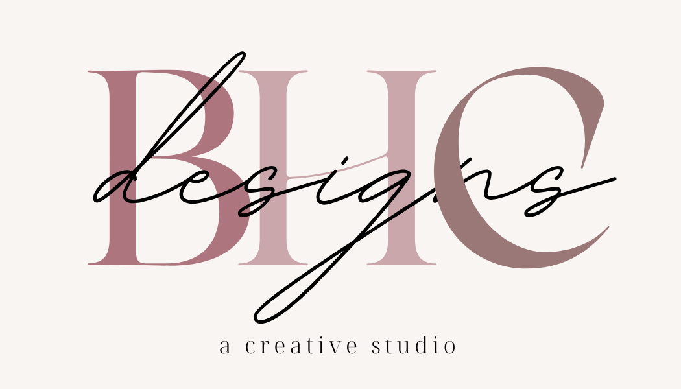**Refund Eligibility**  
   Refunds are only available for services where work has not yet begun. If BHC Designs has commenced substantial work or delivered any assets, no refunds will be issued.
3. **Non-refundable Services**
   * Domain registration fees
   * Third-party platform fees (such as hosting services)
   * Completed design work that has been approved or finalized
4. **Revisions**  
   We offer up to two rounds of revisions on design projects to ensure your satisfaction. Refunds will not be issued once revisions have begun or if you have approved the design.
5. **Project Termination**  
   If the client wishes to terminate the project after the contract is signed and work has begun, all payments made up to that point will be retained by BHC Designs.
6. **Refund Process**  
   Approved refunds will be processed within 10 business days and will be issued via the original method of payment.